Git and GitHub task 02

1. Install Git
Download from https://git-scm.com/downloads
Check installation: git –version
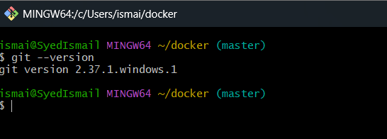

2. Create a repository in GitHub with README.md and .ignore
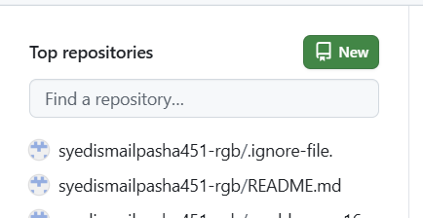

3. Clone the created repository to local
To clone the repository to local
git clone <ssh url from github>

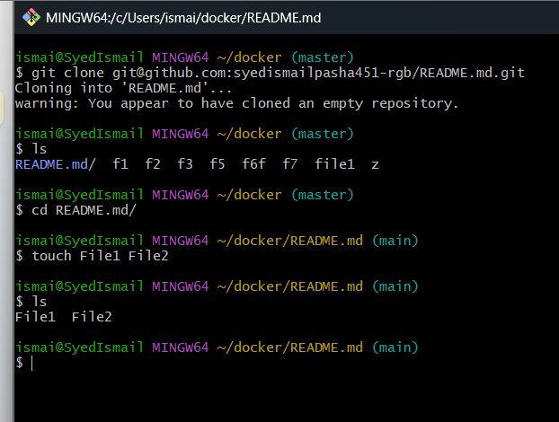

Commit two files and push to central Repository.
4. Create two files in local repository
file1 and file2 are created in local repository
touch file1 file2

5. Commit two files and push to central repository
To add files to central repository, we need to add files to tracking area
git add .
Then commit the files and add commit message
git commit -m “added two files”
Then push the files to central repository
git push -u origin master

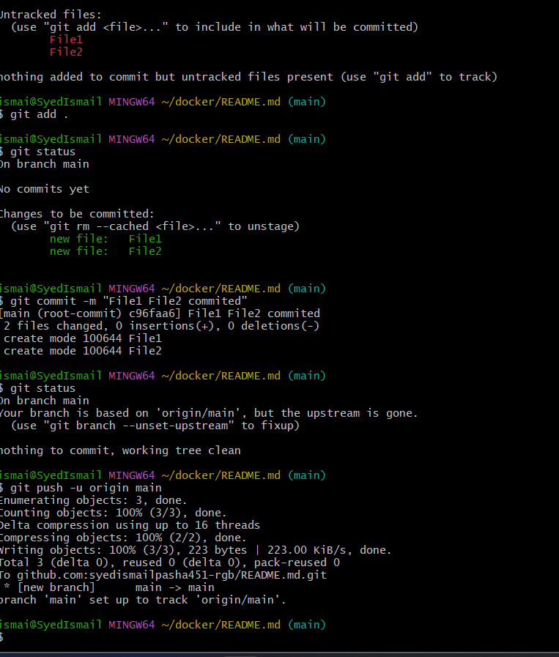

6. Create a branch in local and create a sample file and push to central
To create a branch in local the command is
git checkout -b sample-branch
-b is to create a branch and switch to it
sample-branch is local branch name
To add a sample file to it use
touch sample-file ---- File will be created named sample-file
Then add and commit the sample-file
git add .
git commit -m “added sample file”
Then push to central repository in git hub
git push -u origin sample-branch

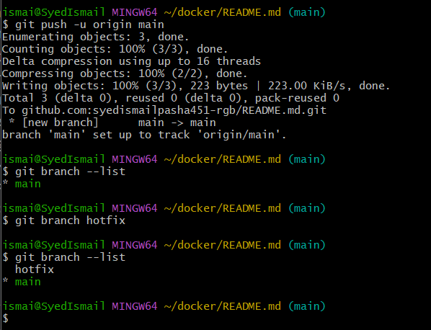

7. Steps: to create new branch from git hub go to git hub and create branch
# to clone the selected branch<git clone –-branch “feature” ssh id
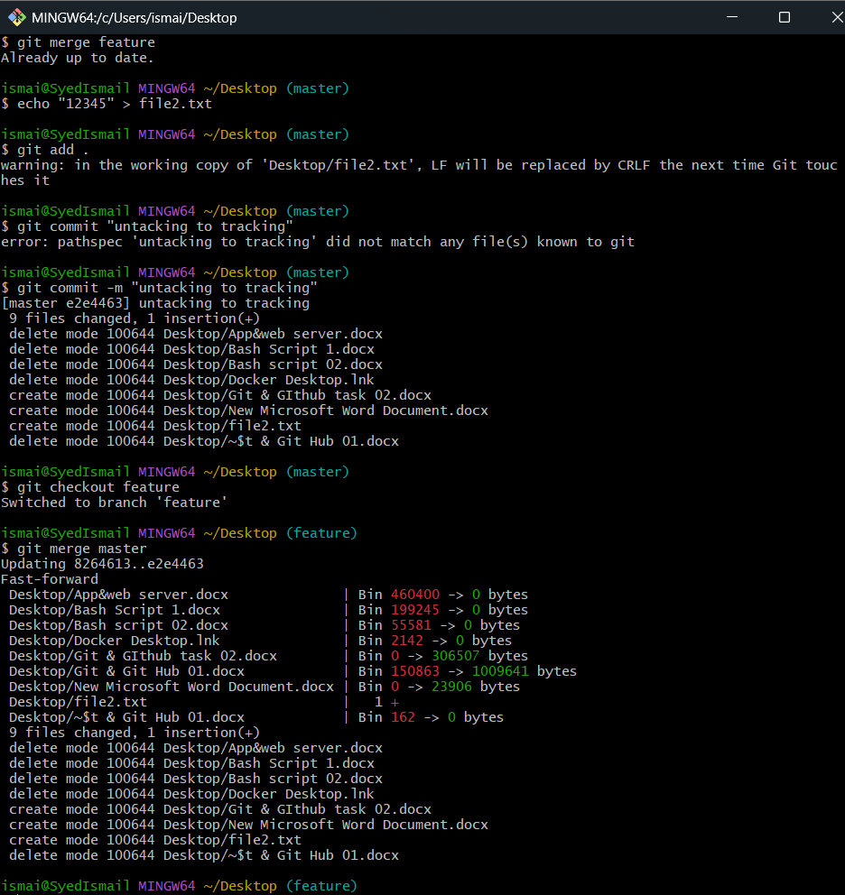

8.Merge the created branch with master in git local.
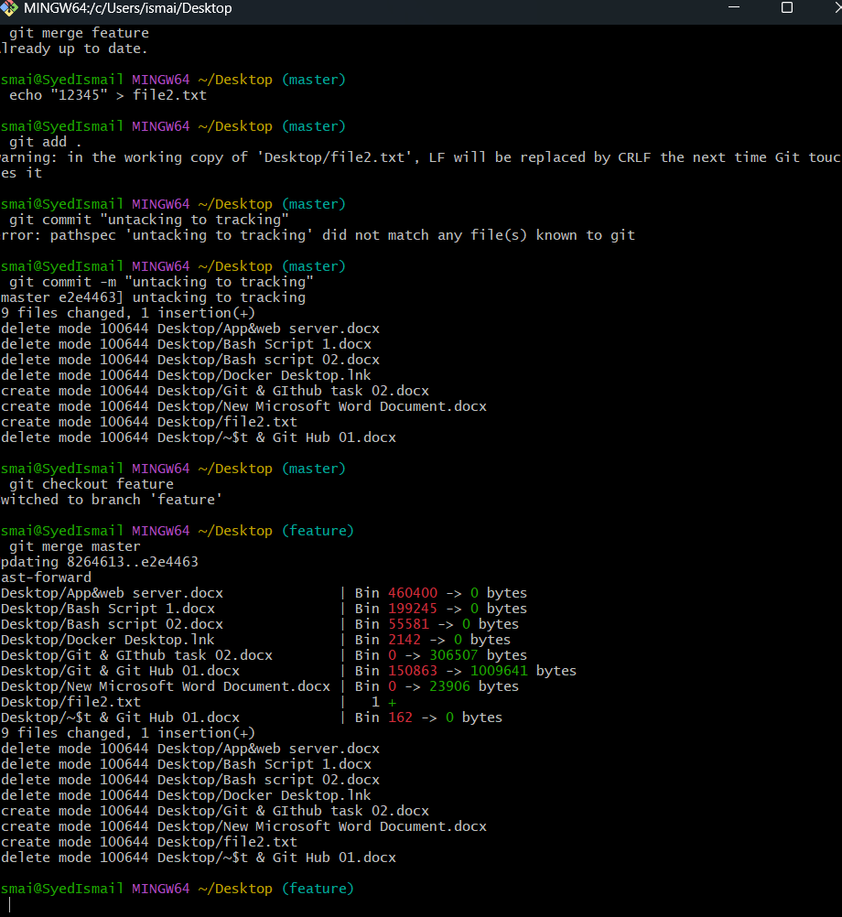

9. Merge the created branch with master in github by sending a pull request
Switch to created branch git checkout new-branch

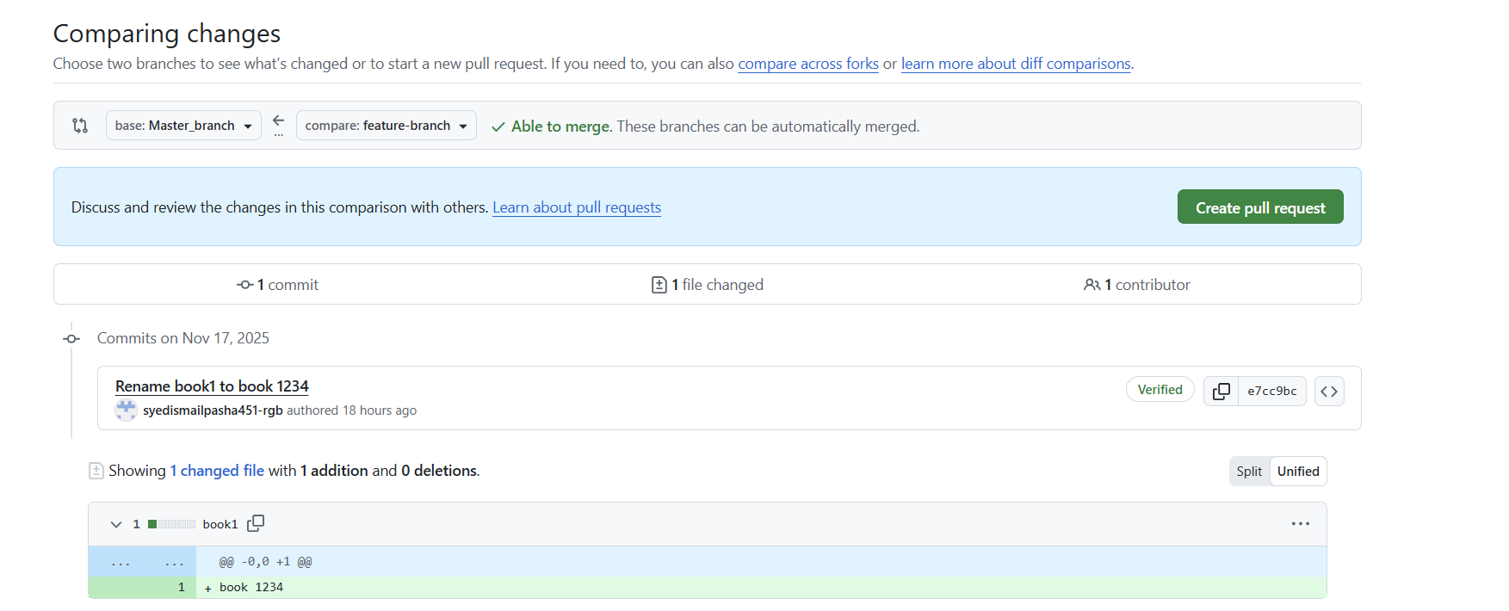
After this we have click on pull request

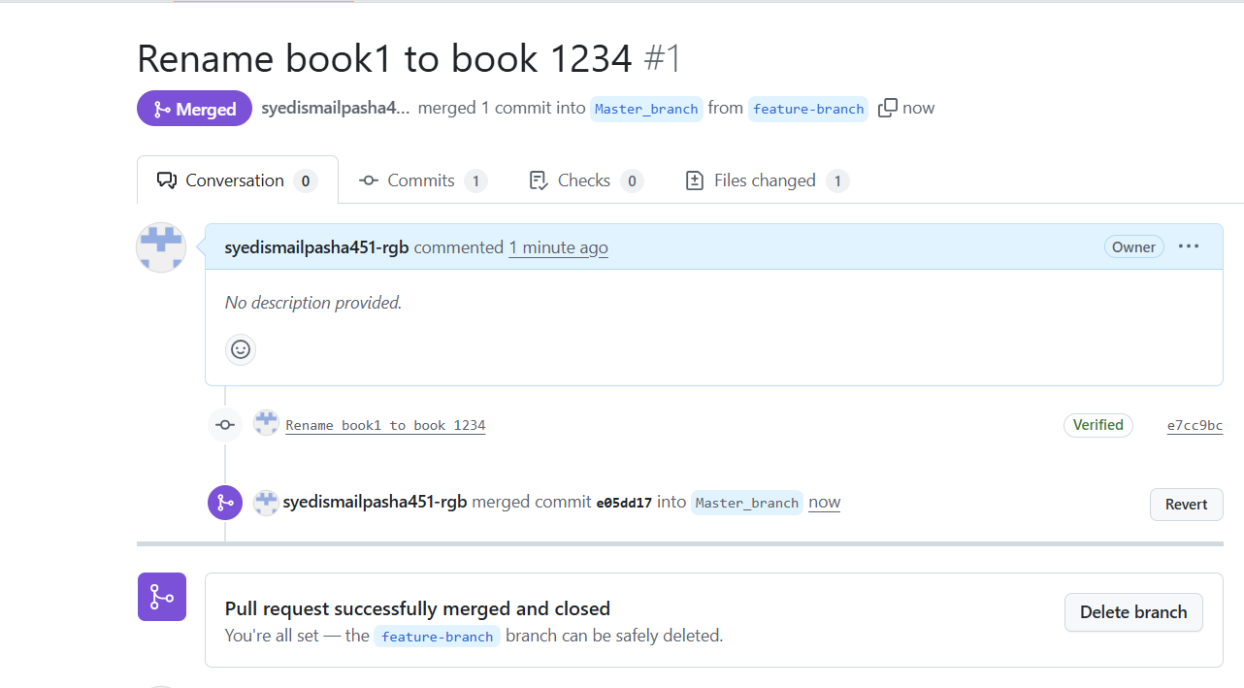

- Create a file in local and send that to branch in github.

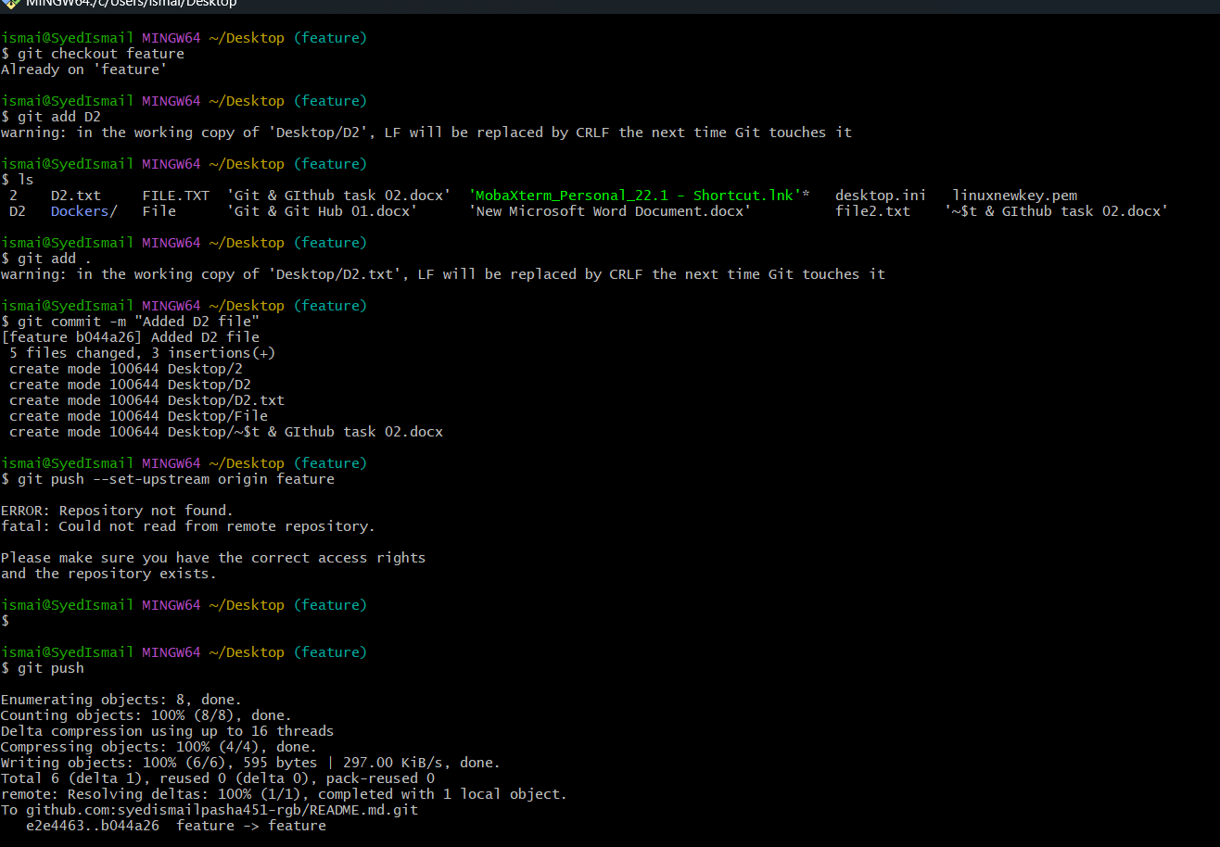

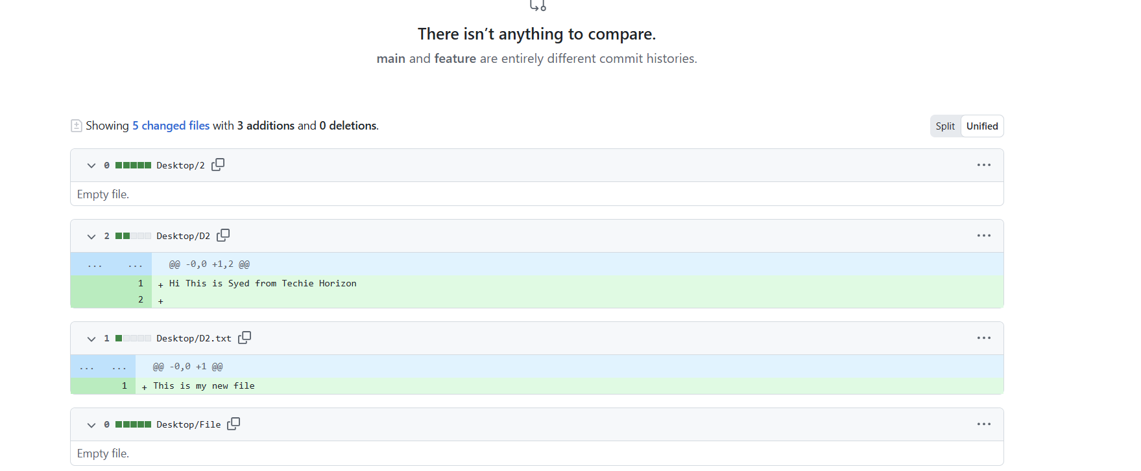
11. Clone only a branch from git hub to local
To clone only one specific branch from git hub we have a command
Git clone {url}

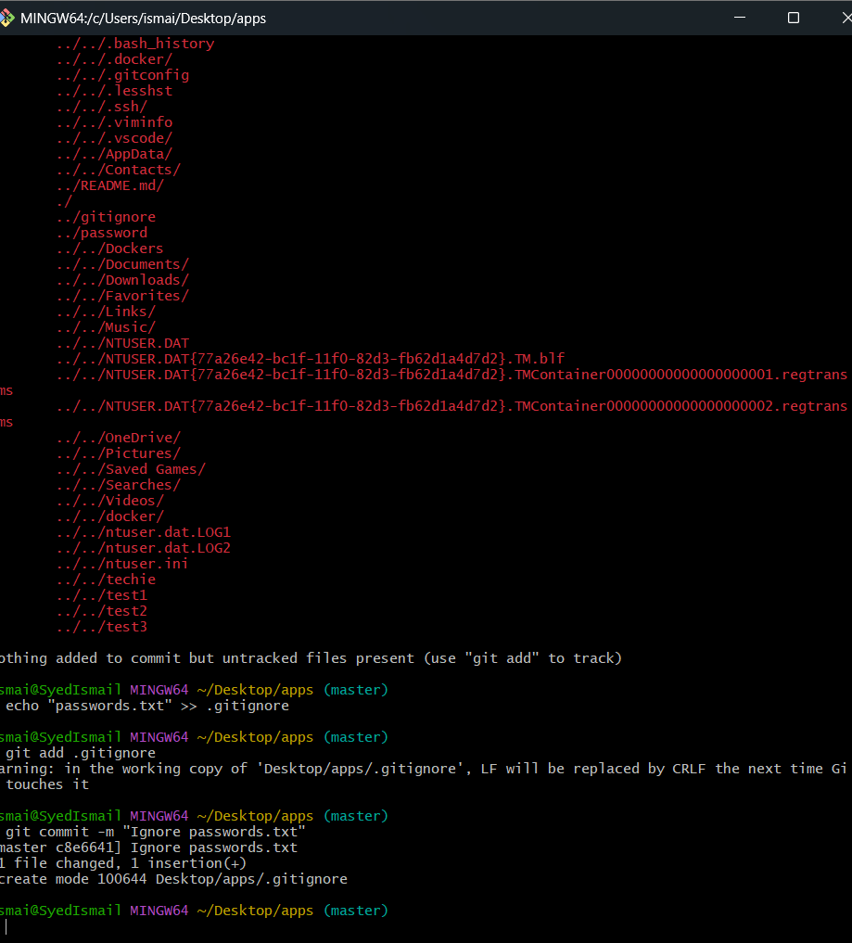

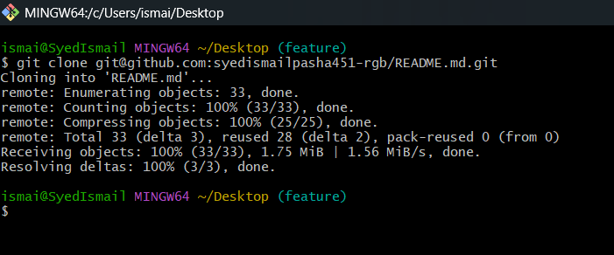

12.Create a file with all passwords and make that untrackable with git.
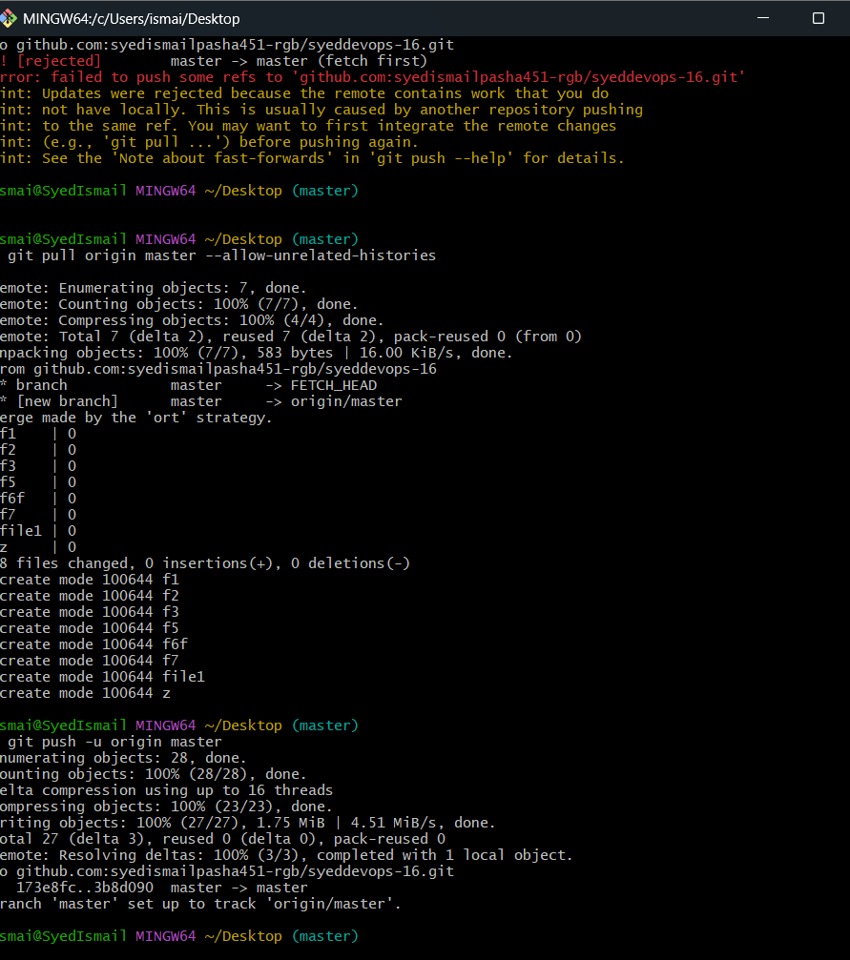
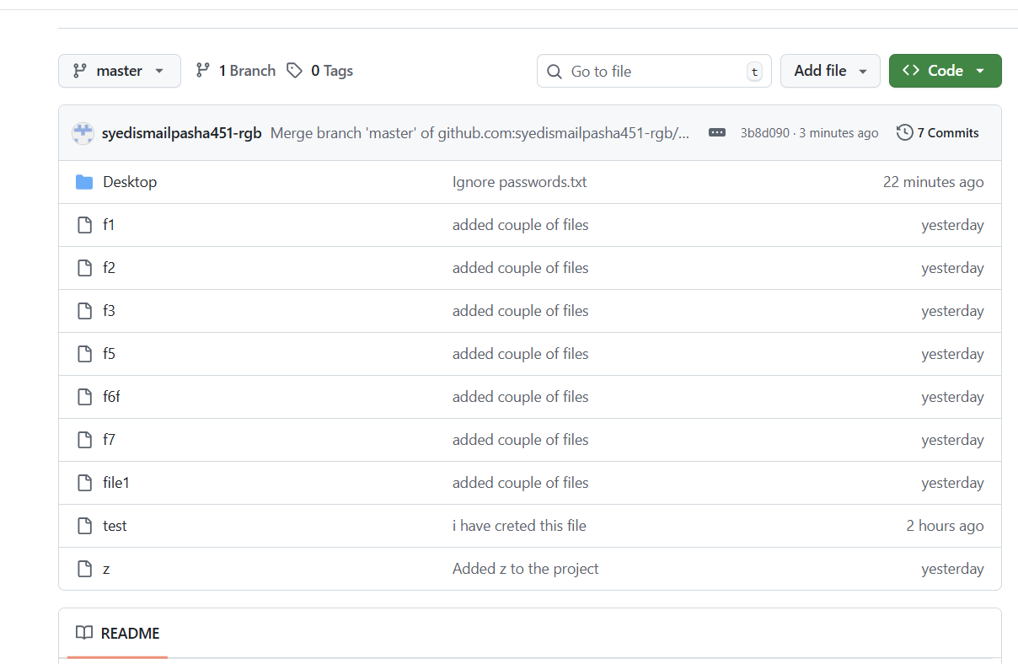

13.Make a commit and make that commit reset without making changes
First make a commit
git add .
git commit -m “my commit”
Reset the commit without making changes
git reset --soft HEAD~1 ---- soft HEAD-1 is used when we have more than 1 commits
To see the commits you have committed in the local machine
git log --oneline
I have created a commit “my commit” and reset that commit without making changes

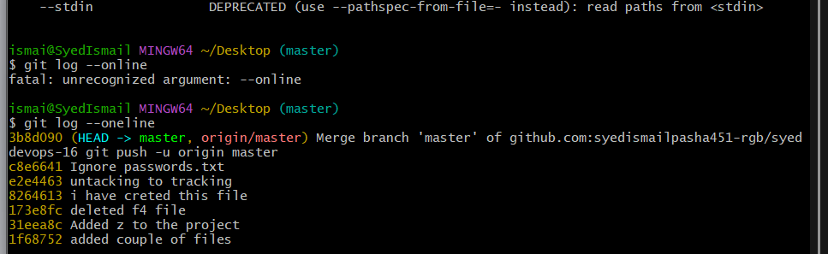

14. 14. Revert the commited commit to the older version

To save your current changes safely and makes your working directory clean
git stash ----- to save current changes
git stash pops ---- to restore earlier changes
To revert the commit which you want to undo
git revert <commit id>
This shows the commit before reverting
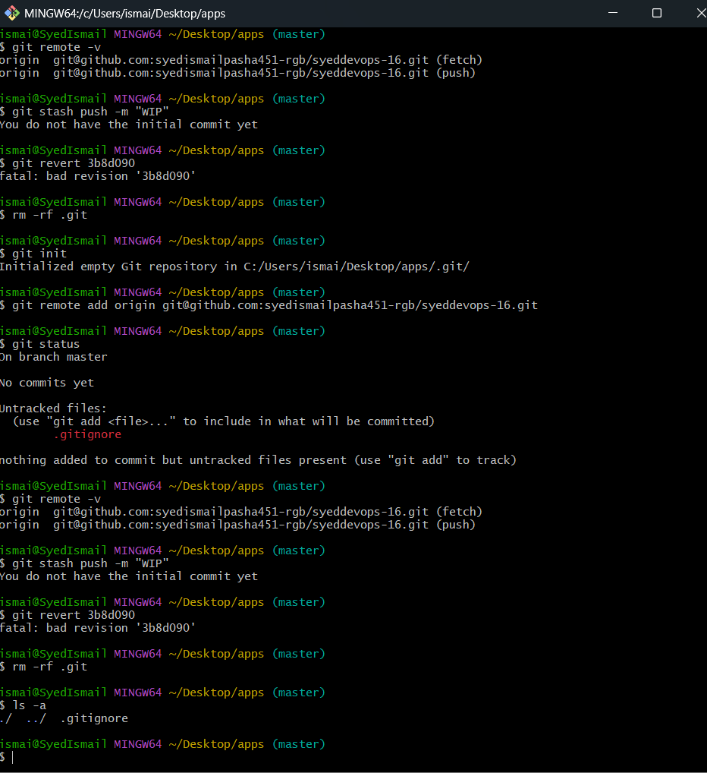

15. Push a file to stash WITHOUT saving the changes and work on another file
git stash list
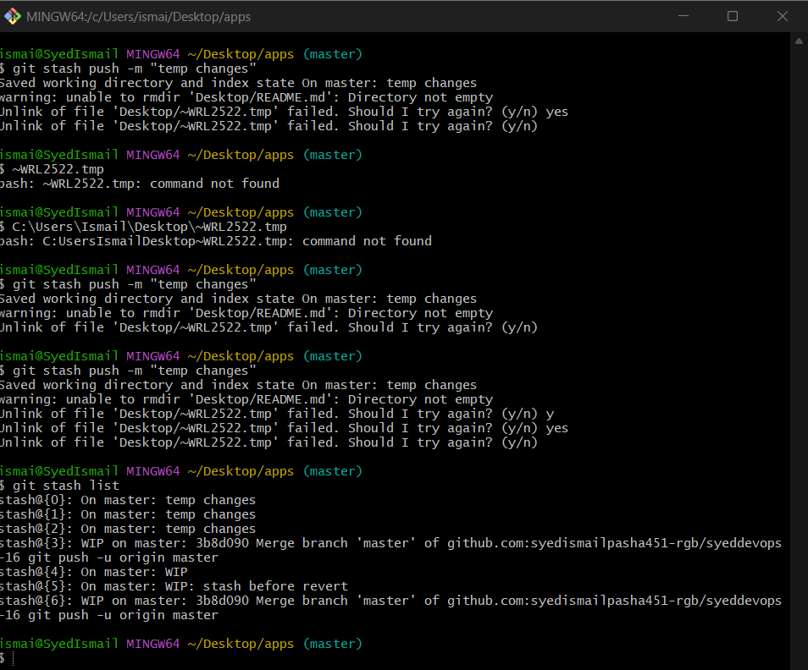

16.Undo the stash file and start working on that again.

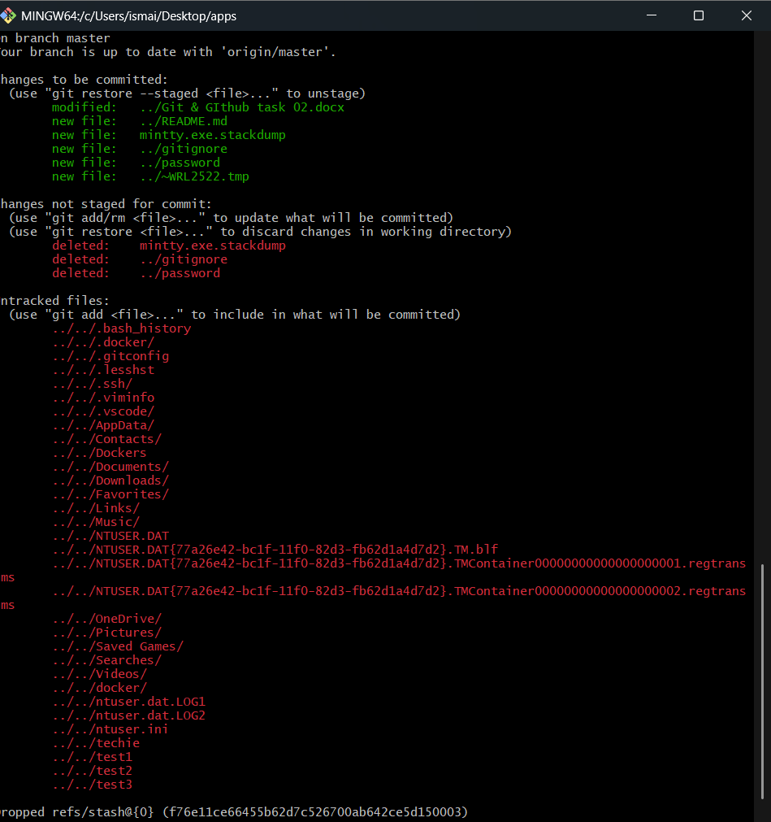

At the bottom of the screenshot, it says:
dropped refs/stash@{0}
(94a57fcde090ef186c3b93aebd76c23e54cffbcb)
This message appears only when you run:
git stash pop
Meaning:
- Your stashed changes were successfully applied
- Your stash entry was deleted (popped)
- Your changes are now back in your working directory
- You can start working on them again

17. Generate an SSH Key and Configure into GitHub

Step 1 — Generate SSH key
Open Git Bash and run:
ssh-keygen -t ed25519 -C "your_email@example.com"
➡ Replace the email with your GitHub email.
When it asks for file location:
Enter a file in which to save the key (/c/Users/Ismail/.ssh/id_ed25519):
Just press:
➡ ENTER
When it asks for a passphrase:
➡ Press ENTER
➡ Press ENTER again
Now your SSH keys are generated.

Step 2 — Start SSH-Agent
Run:
eval "$(ssh-agent -s)"
You will see something like:
Agent pid 1234
This means SSH agent is running.

Step 3 — Add your SSH key to the agent
Run:
ssh-add ~/.ssh/id_ed25519
This adds the private key to your SSH agent.
Step 4 — Add the SSH key to GitHub
Now copy your public key:
cat ~/.ssh/id_ed25519.pub
You will see something like:
ssh-ed25519 AAAAC3NzaC1lZDI1NTE5AAAAIGv...
✔ Copy EVERYTHING (the whole line)

Now go to GitHub:
1. Click your profile (top right)
2. Settings
3. SSH and GPG Keys
4. New SSH Key
- Title: My Laptop Key
- Key type: Authentication Key
- Key: paste the full key here
- Click Add SSH Key

Step 5 — Test the SSH Connection
Run this:
ssh -T git@github.com
If everything is correct, GitHub will reply:
Hi syedismailpasha451-rgb! You’ve successfully authenticated

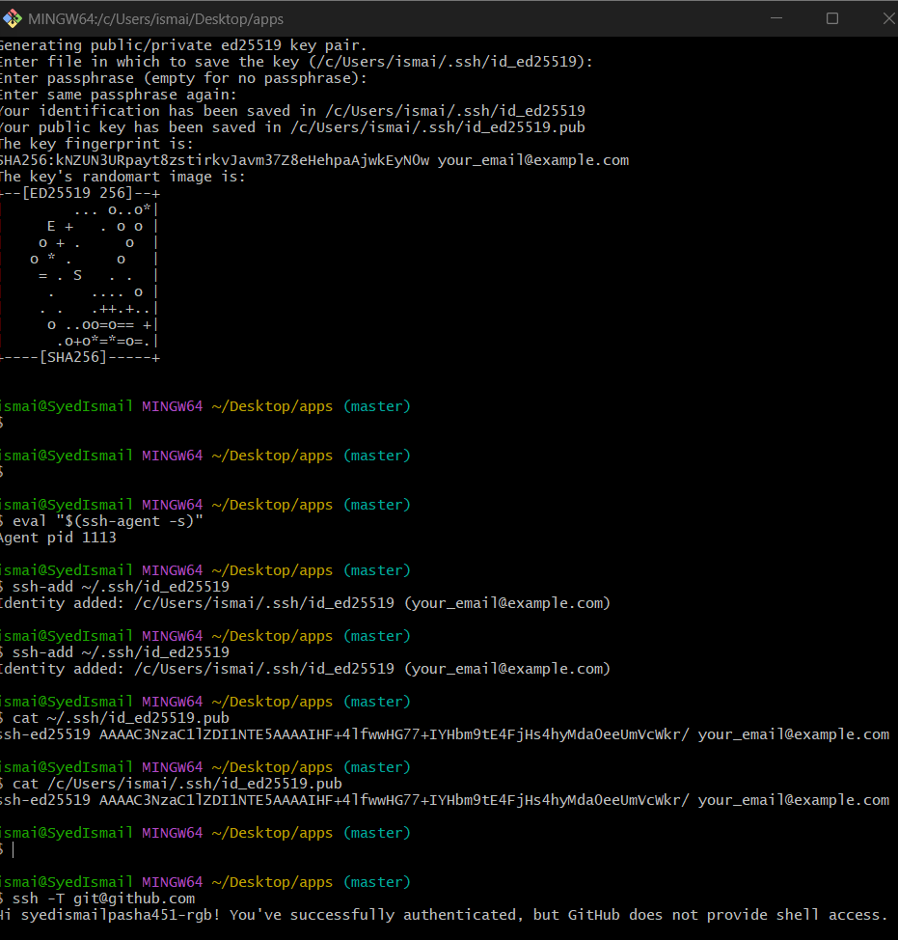

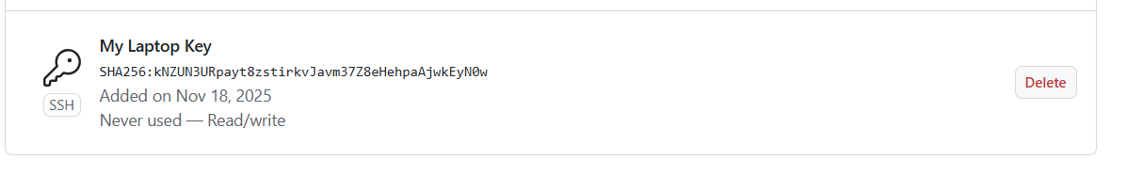

19 Task 19: Basic Understanding of the .git Folder
When you run:
git init
Git creates a hidden folder named:
.git
This folder contains everything Git needs to track your project.
It’s the heart of Git.

Why is .git important?
Without .git, your project is not a Git repository
If you delete .git → all commit history is gone
git stores commits, branches, logs, HEAD pointers, configuration

Inside the .git folder
Here are the most important files/folders inside .git:

1. HEAD
This file tells Git which branch you’re currently on.
Example content:
ref: refs/heads/master
Meaning: You are on the master branch.
2 config
This file contains git configuration for the repository.
Example:
[user]
name = Syed Ismail
email = syed@example.com
And remote:
[remote "origin"]
url = git@github.com:username/repo.git

3. objects/
This is the most important Git folder.
Git stores everything here as objects:
- commits
- trees (folder structure)
- blobs (file content)
- tags
Git compresses everything for storage.
4. refs/
Contains pointers to:
- heads → your branches
- tags → your tags
- remotes → remote branches
Example:
refs/heads/master
refs/remotes/origin/master

5. logs/
Stores all reflog history — each action you took.
Example:
- commit
- checkout
- reset
- rebase
- merge

6. hooks/
Contains scripts that run automatically when certain Git events happen.
Example hooks:
- pre-commit
- pre-push
- post-merge
These are useful in DevOps/CI pipelines.

7. index
This is the staging area.
Whenever you run:
git add <file>
Git stores the file in index before committing.

8. packed-refs
Git packs references to improve performance when repo grows large.

Summary (Very Easy)
Folder/File | Purpose
HEAD | Current branch pointer
config | Repository configuration
objects/ | Stores commit data and file contents
refs/ | Stores branches & tags
logs/ | History of Git operations
hooks/ | Automation scripts (DevOps)
index | Staging area

20. Check all the logs of git.

Step 1 — Add all files
git add .

Step 2 — Commit your files
git commit -m "initial commit"

Step 3 — Now check logs
git log
or
git log --oneline
Now you will see your commit history properly.

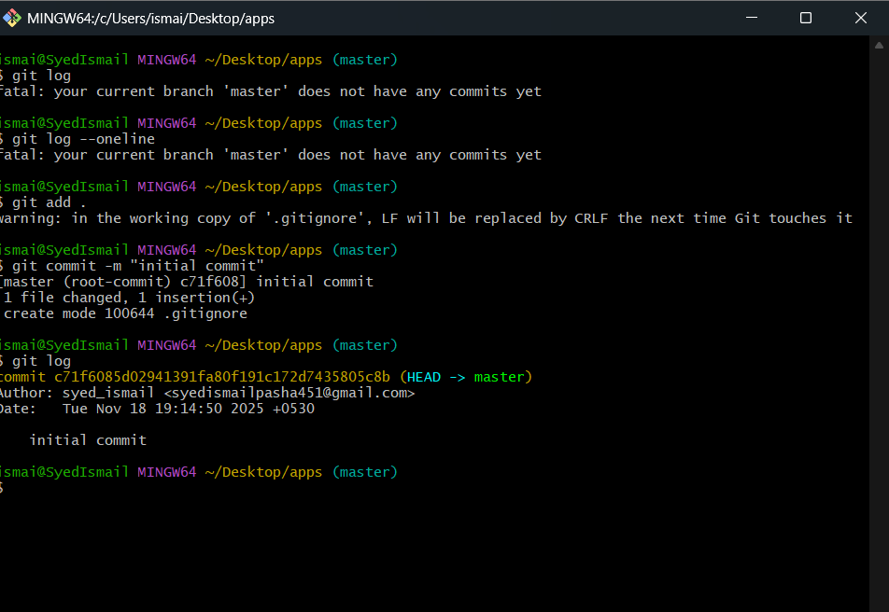

21: Rename the Commit Message

Step 1 — Rename the last commit message
Run this:
git commit --amend -m "Updated initial commit message"
This does not change your code — only the commit message.

Step 2 — Verify
Run:
git log --oneline
You will now see a new message.

Example Output:
a3b5c9f Updated initial commit message

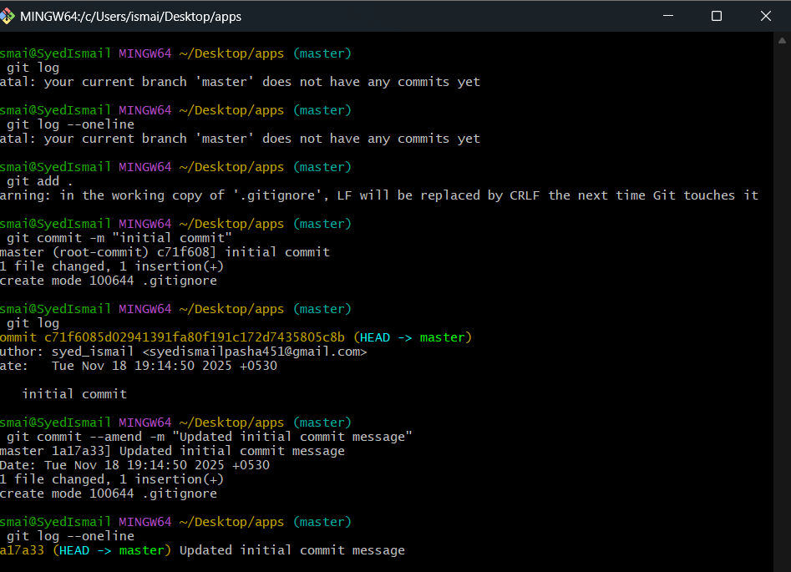

22. Merge multiple commits into single commit.
Merge multiple commits into single
git rebase -i HEAD~3
